

A REPORT ON

PathWise

Submitted To
IEEE TechForGood 2026
In Association with IEEE Student Branch, MIT ADT University
In Collaboration with IEEE Maharashtra Section and IEEE Region 10 AIPSCC

By

Team Name: HexCorp
Member 1: Vedant Dusane — Frontend & UI Developer, Team Lead & GitHub Setup
Member 2: Arnav Kumar — Research, Literature Survey & AI Integration
Member 3: Saqlain Abidi — Backend Developer, Systems Integration & Research
Member 4: Sumit Ghavri — Database & System Architect

Mentor: Dr. Aparna Hambarde
Duration: 1st June – 30th June 2026 | Mode: Fully Remote

Week Number: Week 1 of 4
Submission Date: 06/06/2026

DECLARATION

We, the team members:

Member 1: Vedant Dusane
Member 2: Sumit Ghavri
Member 3: Arnav Kumar
Member 4: Saqlain Abidi

Hereby declare that the project work incorporated in the present project entitled PathWise is original work. We have properly acknowledged the material collected from secondary sources wherever required. We solely own the responsibility for the originality of the entire content.

Date: 01/06/2026

Mentor Name: Dr. Aparna Hambarde
Place: Pune
Date: 01/06/2026

ABSTRACT

Education in India has always followed a single pace for an entire classroom, but every student learns differently. PathWise was built with this gap in mind an adaptive learning platform for students in Classes 1 to 10 studying under CBSE, ICSE, or State Board curricula. Instead of delivering the same content to everyone, the platform tracks where each student struggles and adjusts the learning path accordingly, generating lessons, notes, and quizzes specific to that student’s board, grade, and current level. On the teacher’s side, a live dashboard gives a clear picture of how every student in the class is progressing. The system is built to work even without a stable internet connection, supports both Hindi and English, and uses Google Gemini 2.0 Flash for AI-generated content. PathWise is not trying to replace a teacher it is trying to make sure no student gets left behind simply because the class moved on.

SYNOPSIS

The Indian school education system serves hundreds of millions of students, yet the classroom model has remained largely unchanged one teacher, one pace, one set of notes for an entire class. A student who has not understood fractions cannot meaningfully move on to algebra, but in a standard classroom, the lesson moves forward regardless. This gap between what a student needs and what they receive is one of the most persistent problems in school education, and it is felt most sharply by students in Tier 2 and Tier 3 cities where access to quality tutoring is limited. PathWise was built to address this directly.
The core idea is simple: every student should have a learning path that is built around them, not around the class average. When a student logs in, the platform generates a personalised topic order based on their grade, board, and self-assessed level. As they attempt quizzes and lessons, the system tracks which concepts they are getting wrong and automatically adjusts what comes next. If three or more topics turn weak, the learning path is regenerated. Quizzes on retry do not repeat the same questions they focus specifically on what the student got wrong last time. The platform covers CBSE, ICSE, and State Board curricula for Classes 1 to 10 across Mathematics, Science, and English.
Lessons and study notes are generated using Google Gemini 2.0 Flash through the OpenRouter API, scoped precisely to the student’s board and grade. An AI chatbot tutor allows students to ask syllabus questions in either Hindi or English, with a built-in offline fallback engine that works without any internet connection. This offline-first design was a deliberate choice many students in India face inconsistent connectivity, and the platform caches lessons, notes, and quizzes locally so learning is never interrupted.
Teachers are not left out of the picture. A dedicated teacher dashboard gives real-time visibility into every student’s progress percentage, streak, last active date, weak areas, and recent quiz scores. Teachers can add or remove syllabus modules for individual students, creating a customized curriculum where needed. Students inactive for five or more days are flagged automatically.
The technology stack includes React 19 and Zustand on the frontend, Express.js on the backend, and SQLite with WAL mode for a fast, lightweight database. The application is deployable as a Progressive Web App, meaning it can be installed on any mobile, tablet, or desktop device without going through an app store. The expected impact of PathWise is meaningful. By making personalized learning accessible without expensive hardware or constant internet, the platform has the potential to genuinely improve learning outcomes for students who would otherwise fall through the cracks of a one-size-fits-all system.

CONTENTS

Section / Chapter | Week | Page
Abstract | Week 1 | i
Synopsis | Week 1 | ii
Chapter 1 — Introduction | Week 1 | 9
Chapter 2 — Literature Survey | Week 1 | 11
Chapter 3 — Concepts and Methods | Week 1 | 12
Chapter 4 — Project Plan, Progress Tracker & GitHub | Week 1 | 15
Chapter 5 — Proposed Solution & Development Progress | Week 2 | 17
Chapter 6 — Results, Testing & Proof of Work | Week 3 | 19
Chapter 7 — Conclusion & Future Scope | Week 4 | 20
Weekly Mentor Meeting Logs (Week 1–4) | Every Week | 21
Weekly Self-Rating & Team Collaboration | Every Week | 27
Bibliography | — | 30
Annexure A — Research Paper/Copyright/Patent | Week 3 & 4 | 31

LIST OF FIGURES

Figure 3.1: [System Architecture Diagram] .................................................... Page 13
Figure 5.1: [Development Screenshot — Feature 1] ........................................ Page __
Figure 5.2: [Development Screenshot — Feature 2] ........................................ Page __
Figure 6.1: [Test Result / UI Output] ........................................................... Page __
Figure M1.1: [Week 1 Mentor Meeting Screenshot] .......................................... Page __
Figure M2.1: [Week 2 Mentor Meeting Screenshot] .......................................... Page __
Figure M3.1: [Week 3 Mentor Meeting Screenshot] .......................................... Page __
Figure M4.1: [Week 4 Mentor Meeting Screenshot] .......................................... Page __

LIST OF TABLES

Table 2.1: Literature Survey ........................................................................ Page 11
Table 4.1: 4-Week Project Timeline ................................................................ Page 15
Table 4.2: Progress Tracker ........................................................................... Page 15
Table M1.1: Week 1 Attendance Record ............................................................. Page __
Table M2.1: Week 2 Attendance Record ............................................................. Page __
Table M3.1: Week 3 Attendance Record ............................................................. Page __
Table M4.1: Week 4 Attendance Record ............................................................. Page __
Table SR.1–4: Weekly Self-Rating Tables (Week 1–4) ........................................... Page __

Chapter 1 INTRODUCTION
[ Complete in Week 1 ]
1.1 BACKGROUND
India has one of the largest school-going populations in the world, with over 250 million students enrolled across government and private schools. Despite this scale, the teaching model in most classrooms remains largely uniform, a single teacher covering a fixed syllabus at a fixed pace for an entire class of 30 to 60 students. The problem is not a lack of effort from teachers, but a structural one: it is simply not possible for one person to track the individual understanding of every student in a large classroom and adjust accordingly. The result is a significant learning gap that grows wider with every passing year. A student who misses a foundational concept in Class 4 carries that gap into Class 5, and by the time it becomes obvious, it is difficult to address without pulling back several chapters. Private tuition exists as a workaround for families who can afford it, but for the majority of students particularly in Tier 2 and Tier 3 cities and rural areas that option is not available. Digital learning tools have tried to fill this space, but most of them replicate the same one-size-fits-all model on a screen, offering the same video or worksheet to every student regardless of where they are in their understanding
1.2 PROBLEM STATEMENT
The core problem PathWise addresses is the absence of personalised learning at scale in Indian school education. Students in Classes 1 to 10 across CBSE, ICSE, and State Board schools are expected to learn at the same pace as their classmates, regardless of their individual strengths and weak areas. When a student falls behind on a concept, there is no mechanism in the standard classroom to detect this early and course-correct before it compounds. This affects students most acutely in subjects like Mathematics and Science, where each chapter builds directly on the one before it. Teachers, despite their best intentions, are constrained by time and class size. Parents often lack the subject knowledge to help at home. Existing edtech tools tend to offer pre-recorded content or static question banks that do not adapt to a student’s actual performance. The result is that a large number of students reach higher classes with unresolved gaps in foundational knowledge, which affects both their academic confidence and their long-term outcomes.
1.3 MOTIVATION
The team chose this problem because it sits at the intersection of two things that matter deeply: education and accessibility. India has no shortage of smart students; what it has a shortage of is infrastructure that can meet each student where they are. The edtech space in India has grown significantly, but most products are either too expensive, too dependent on fast internet, or not aligned with the specific boards and syllabuses that most Indian students follow. PathWise was conceived as a response to this gap. The goal was to build something that a student in a small town with an inconsistent internet connection could use just as effectively as a student in a metro city with a reliable connection. The offline-first architecture, bilingual support, and board-specific curriculum alignment were all decisions made with this in mind. The societal need is real if a student can identify and address their weak concepts early, their academic trajectory changes. That is the outcome PathWise is working toward.
1.4 OBJECTIVES
The following are the core objectives of PathWise:
- To develop an AI-powered adaptive learning platform that generates personalised learning paths for students in Classes 1–10 across CBSE, ICSE, and State Board curricula.
- To build an offline-first system that caches lessons, notes, and quizzes locally so students can continue learning without an active internet connection.
- To provide teachers with a real-time dashboard that tracks individual student progress, highlights weak areas, and flags inactivity, enabling better classroom intervention.
1.5 SCOPE OF THE PROJECT
PathWise covers Classes 1 to 10 across three boards: CBSE, ICSE, and State Board. The subjects included are Mathematics, Science, and English. The platform supports two languages Hindi and English for both the student interface and the AI chatbot tutor. The scope includes: personalised learning path generation, adaptive quiz engine, AI-generated lessons and notes, offline caching and sync, a teacher dashboard with class management features, and a Progressive Web App that works on mobile, tablet, and desktop. The scope does not include: live video classes, human tutoring services, Classes 11 and 12 or competitive exam preparation (JEE, NEET, etc.), regional languages beyond Hindi and English, or integration with any school ERP or official board examination systems. These are potential future additions but fall outside the boundaries of this internship project.

Chapter 2 LITERATURE SURVEY
[ Complete in Week 1 ]
2.1 EXISTING RESEARCH AND SOLUTIONS
Sr | Author(s) | Title | Key Contribution | Gap Identified
1 | Vandewaetere et al. | The Contribution of Learner Characteristics in the Development of Computer-Based Adaptive Learning Environments | Demonstrated that adaptive systems outperform static ones when content is matched to a learner’s current knowledge state | Most adaptive systems studied were designed for higher education; limited application to school-level curricula in developing countries
2 | Mitrovic, Martin & Suraweera | Intelligent Tutors for All: The Constraint-Based Approach | Introduced a constraint-based intelligent tutoring system that provides personalized feedback and guidance by analyzing learner mistakes and knowledge gaps. | The approach primarily focused on intelligent tutoring and lacked integration with comprehensive learning analytics, curriculum alignment, and multilingual educational support.
3 | Bodily & Verbert | Review of Research on Student-Facing Learning Analytics Dashboards and Educational Recommender Systems | Highlighted the effectiveness of learning analytics dashboards and recommender systems in tracking student progress and delivering personalized educational recommendations. | Existing solutions mainly targeted higher education and lacked offline accessibility, board-specific personalization, and integration with adaptive content generation for school students.
Table 2.1 — Literature Survey
2.2 IDENTIFIED GAPS
The literature consistently points to three gaps that PathWise directly addresses. First, most adaptive learning systems studied in research are designed for university-level or corporate training contexts; very few have been built specifically for school students following Indian boards like CBSE, ICSE, or State Board curricula. Second, existing edtech platforms in India either require a stable internet connection or offer static content that does not adapt to individual performance. Third, bilingual support particularly for Hindi-medium or Hindi-comfortable students is almost entirely absent from adaptive learning tools. PathWise addresses all three gaps: it is built around the Indian school syllabus from the ground up, it functions offline through local caching and a built-in fallback AI engine, and it supports both Hindi and English throughout the platform. The adaptive quiz engine that focuses on concepts a student got wrong on the previous attempt is a direct response to the gap identified in adaptive system research that meaningful personalisation requires acting on specific error patterns, not just overall scores.

Chapter 3 CONCEPTS AND METHODS
[ Complete in Week 1 ]
3.1 TECHNOLOGY STACK
The technology choices for PathWise were made with three priorities in mind: performance, offline capability, and ease of deployment for a remote student population. On the frontend, the team chose React 19 with Vite 6 for fast builds and a smooth development experience. Zustand was selected for global state management due to its simplicity compared to Redux, which would have added unnecessary complexity for the scope of this project. React Router 7 handles client-side navigation. The application is built as a Progressive Web App so it can be installed on any device without an app store. The backend runs on Express.js with Node.js in ESM mode. The database is SQLite via the better-sqlite3 library, configured with WAL mode and a 16MB cache for fast concurrent reads. SQLite was chosen deliberately over a cloud database because it runs entirely on the server without external dependencies, which simplifies deployment and keeps costs at zero for a student-facing platform. For AI content generation, the team integrated Google Gemini 2.0 Flash through the OpenRouter API. Gemini Flash was selected for its speed and cost-effectiveness it generates board-aligned lessons and quizzes quickly without the latency of heavier models. A built-in local AI engine serves as a fallback when the API is unavailable, ensuring the platform continues to function offline. The application is deployed on Vercel, which handles both the static frontend and the serverless backend without requiring a dedicated server.
3.2 SYSTEM ARCHITECTURE
PathWise follows a client-server architecture with an offline-first layer on the client side. The React frontend communicates with an Express.js backend over a REST API. The backend handles authentication, learning path generation, quiz logic, content generation, and teacher dashboard data, all stored in a SQLite database. When a student is online, AI-generated content is fetched from the server, which calls the OpenRouter API to invoke Google Gemini 2.0 Flash. The response is returned to the client and simultaneously cached by the service worker for offline use. When the student is offline, the service worker serves cached content directly, and any quiz results or interactions are queued locally and synced automatically when the connection is restored. The teacher dashboard operates on the same backend, reading aggregated student data from the SQLite database in real time. Class management including syllabus customisation and class code enrolment is handled through dedicated teacher API routes.

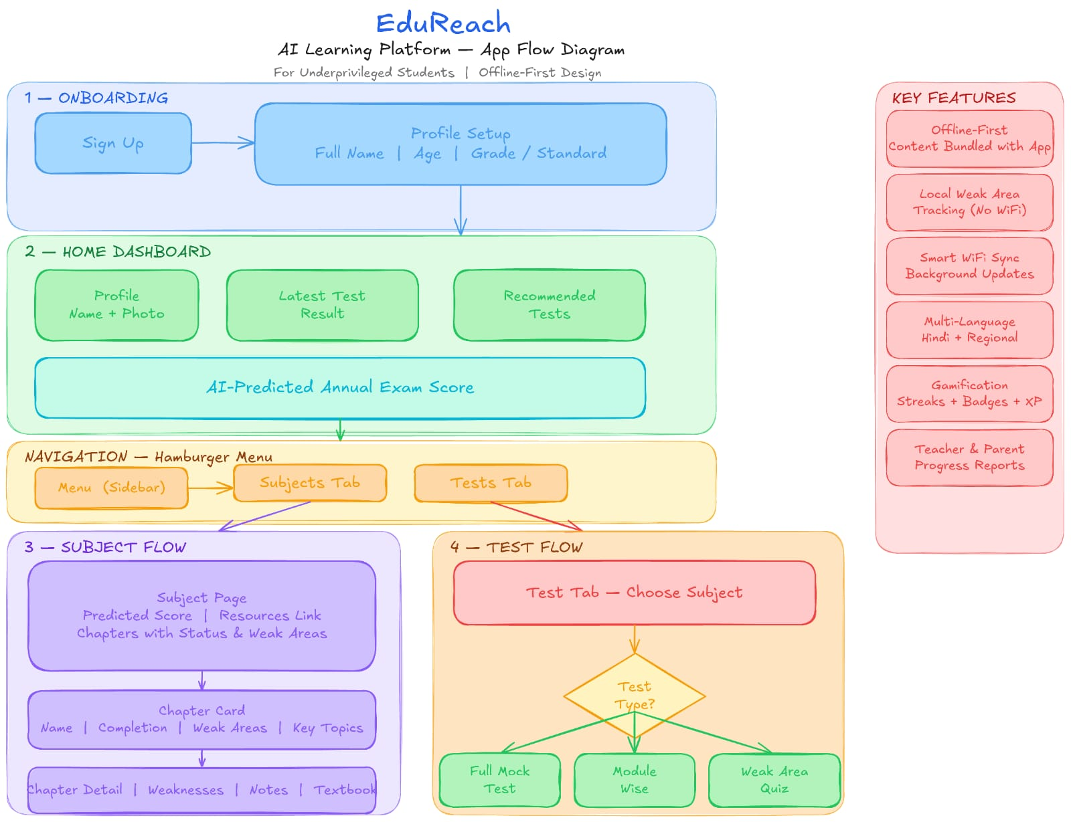
Figure 3.1 — System Architecture Diagram

3.3 DEVELOPMENT METHODOLOGY
The team is following an iterative Agile methodology, structured around the four-week timeline of the internship. Each week functions as a sprint with defined deliverables. Daily communication happens over WhatsApp, and the team holds a structured check-in twice a week to review progress and resolve blockers. Tasks are divided by area of ownership: Vedant handles the frontend and UI, Arnav manages the database schema and offline architecture, Saqlain leads research, literature review, and AI integration, and Sumit owns the backend routes, API integration, and the glue code that connects all layers. Research contributions are shared between Saqlain and Sumit. The GitHub repository is the single source of truth for code. All features are developed on separate branches and merged into main after review. Commit history serves as the primary progress log alongside the weekly report.

Chapter 4 PROJECT PLAN
[ Complete in Week 1 ]
4.1 4-WEEK TIMELINE AND MILESTONES

The internship project is structured across four weeks as outlined below.
Week | Phase | Key Activities | Deliverable
Week 1 | Ideation & Setup | Problem identification, tech selection, project plan, GitHub setup, literature survey | Chapters 1–4
Week 2 | Core Development | Active development, mentor check-ins, feature building, progress tracking | Chapter 5 + MVP
Week 3 | Refinement & Testing | Debugging, optimisation, UI/UX improvements, test results, screenshots | Chapter 6 + Tests
Week 4 | Documentation & Final | Final report, demo video, research paper, final presentation | Chapter 7 + Paper
Table 4.1 — 4-Week Project Timeline

4.2 PROGRESS TRACKER
Task / Milestone | Assigned To | Start | Deadline | Status | %
Problem identification, board/syllabus research, and project scoping | Vedant Dusane | 01/06 | 02/06 | Completed | 100%
GitHub repository setup, folder structure, Express + React scaffolding | Saqlain Abidi | 01/06 | 04/06 | Completed | 100%
Literature survey — gather and summarise 3+ relevant research papers | Arnav Kumar | 01/06 | 05/06 | Completed | 100%
Database schema design and SQLite setup with WAL mode and indexes | Sumit Ghavri | 01/06 | 03/06 | Completed | 100%
Table 4.2 — Progress Tracker (Update Weekly)

4.3 OVERALL COMPLETION STATUS
Week 1 Target: | ~15% — Planning, ideation, and setup complete
Week 2 Target: | ~45% — Core features developed
Week 3 Target: | ~80% — Tested, refined, and results compiled
Week 4 Target: | 100% — Final report, demo, and paper submitted

4.4 GITHUB REPOSITORY
Repository URL: | https://github.com/HexCorp-HexTech/PathWise
Primary Branch: | main
Last Updated: | 06/06/2026

Chapter 5 PROPOSED SOLUTION AND DEVELOPMENT PROGRESS
[ Update in Week 2 ]
5.1 PROPOSED SOLUTION OVERVIEW
[Describe the proposed solution in detail. What does your system do? How does it solve the identified problem?]
5.2 KEY FEATURES
- [Feature 1]
- [Feature 2]
- [Feature 3]
5.3 TARGET AUDIENCE
[Who will use this system? Describe your end users and their needs.]
5.4 DIFFERENTIATION FROM EXISTING SOLUTIONS
[What makes your solution unique? How is it better or different from what already exists?]
5.5 WEEK 2 — DEVELOPMENT PROGRESS

Week 2 — Planned | Week 2 — Completed
• [Planned task 1]  • [Planned task 2]  • [Planned task 3] | • [Completed task 1]  • [Completed task 2]  • [Completed task 3]

5.6 PROOF OF WORK — DEVELOPMENT SCREENSHOTS
[Add screenshots of code, UI, or working features developed in Week 2. Label each with a figure number and caption.]

[ Insert Screenshot Here ]
Figure 5.1 — Development Screenshot (Week 2)

[ Insert Screenshot Here ]
Figure 5.2 — Development Screenshot (Week 2)

Chapter 6 RESULTS, TESTING AND PROOF OF WORK
[ Complete in Week 3 ]
6.1 TESTING METHODOLOGY
[How did you test the project? Unit testing, integration testing, user testing? Describe your approach.]
6.2 TEST RESULTS AND OBSERVATIONS
[What were the outcomes of your tests? Include pass/fail data, accuracy, performance metrics, etc.]
6.3 SYSTEM PERFORMANCE
[Describe overall system performance — speed, reliability, accuracy, or other relevant metrics.]
6.4 VISUAL OUTPUTS AND PROOF OF WORK
[Insert graphs, screenshots, test reports, and demo outputs here. Each image must include a figure number and caption.]

[ Insert Screenshot Here ]
Figure 6.1 — Test Result / UI Output (Week 3)

[ Insert Screenshot Here ]
Figure 6.2 — Performance Graph / System Output (Week 3)

Chapter 7 CONCLUSION AND FUTURE SCOPE
[ Complete in Week 4 ]
7.1 KEY FINDINGS AND ACHIEVEMENTS
[Summarise what your team achieved during the internship. What problem was solved? What was built?]
7.2 LIMITATIONS
[State the limitations of your current system honestly. What could not be achieved within the given time or resources?]
7.3 FUTURE SCOPE
[What are the next steps for this project? What features or improvements can be added in future?]
7.4 FINAL DELIVERABLES CHECKLIST

Deliverable | Status | Submitted
Functional MVP / Working Project | Complete / Pending | Yes / No
Technical Report (This Document) | Complete / Pending | Yes / No
Project Demo Video | Complete / Pending | Yes / No
Research / Conference Paper | Complete / Pending | Yes / No
All 4 Weekly Progress Reports | Complete / Pending | Yes / No
GitHub Repository Link | Complete / Pending | Yes / No

WEEKLY MENTOR MEETING LOGS

WEEK 1 — MENTOR MEETING LOG

Date of Meeting: | 09/06/2026
Mode: | Google Meet
Duration: | 11:00 — 12:00
GitHub Commit (this week): | https://github.com/HexCorp-HexTech/PathWise

ATTENDANCE RECORD

Team Member | Role | Attended | Remarks
Member 1 — Vedant Dusane | Frontend & UI Developer, Team Lead & GitHub Setup | Yes | —
Member 2 — Sumit Ghavri | Database & System Architect | Yes | —
Member 3 — Saqlain Abidi | [Role] | No | —
Member 4 — Arnav Kumar | [Role] | No | —

KEY DISCUSSION POINTS
- Report
- Stack of application
- Key Features Of Application
- Suggestions made for the next version
  - Parent signing
  - Recommend algorithm
  - Learning algo
  - Video Lectures

MENTOR FEEDBACK
[Summarise the feedback, suggestions, and direction given by the mentor this week]

MENTOR MEETING SCREENSHOT

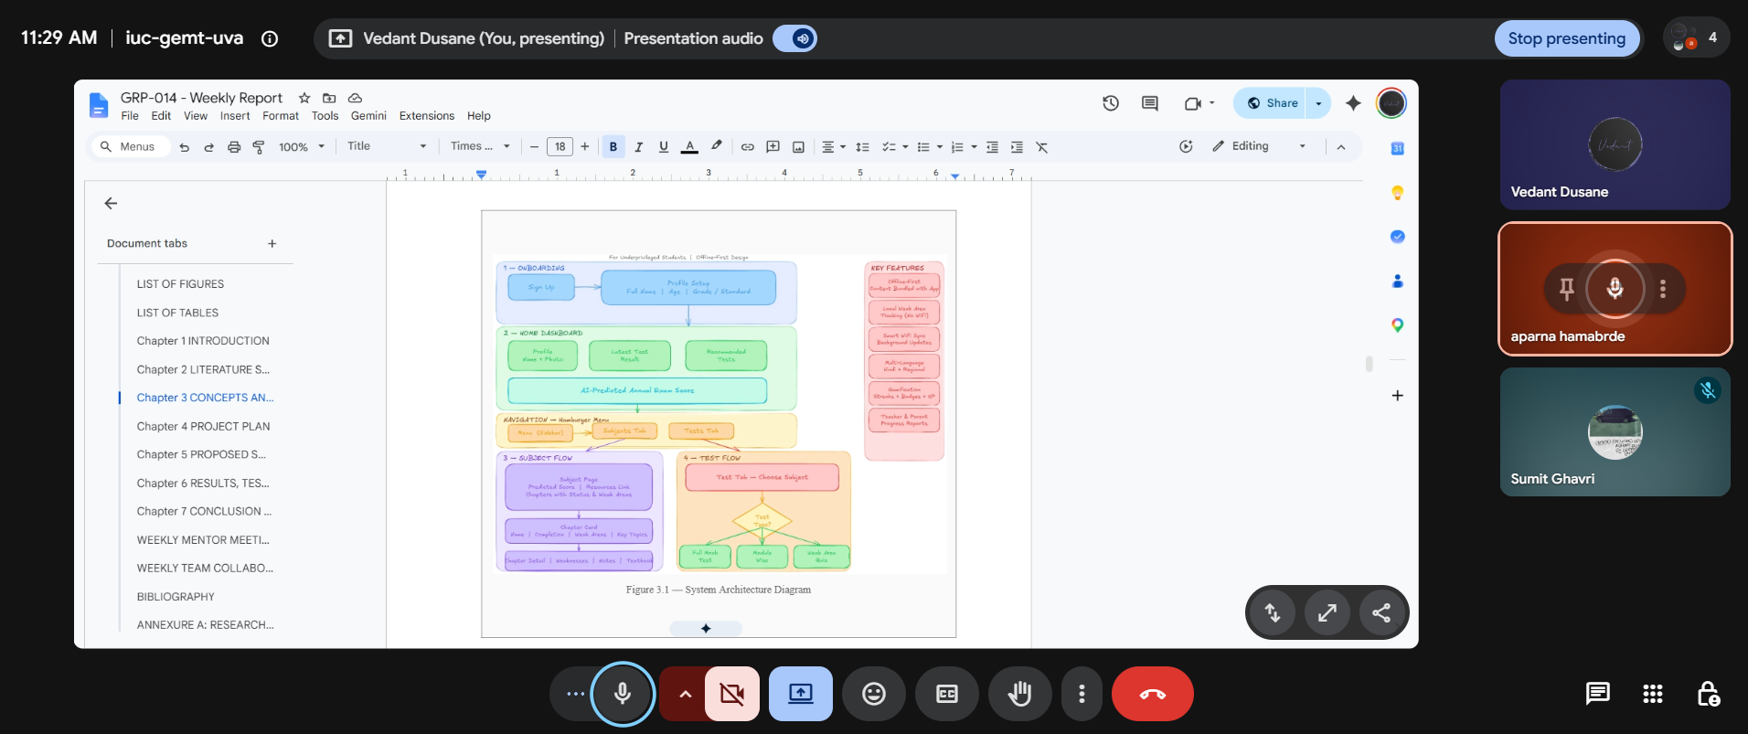
Figure M1.1 — Week 1 Mentor Meeting Screenshot

MENTOR SIGN-OFF

Mentor Feedback & Comments | Mentor Sign-Off
[Mentor fills feedback here] | Name: ___________________________  Signature: ______________________  Date: ___________________________

WEEK 2 — MENTOR MEETING LOG

Date of Meeting: | [DD/MM/YYYY]
Mode: | Google Meet / Zoom / WhatsApp / Other
Duration: | [HH:MM — HH:MM]
GitHub Commit (this week): | https://github.com/[repo]/commit/[hash]

ATTENDANCE RECORD

Team Member | Role | Attended | Remarks
Member 1 — [Name] | [Role] | Yes / No | —
Member 2 — [Name] | [Role] | Yes / No | —
Member 3 — [Name] | [Role] | Yes / No | —
Member 4 — [Name] | [Role] | Yes / No | —

KEY DISCUSSION POINTS
[Bullet-point summary of what was discussed in this meeting]
• [Point 1]
• [Point 2]
• [Point 3]

MENTOR FEEDBACK
[Summarise the feedback, suggestions, and direction given by the mentor this week]

MENTOR MEETING SCREENSHOT

[ Insert Screenshot Here ]
Figure M2.1 — Week 2 Mentor Meeting Screenshot

MENTOR SIGN-OFF

Mentor Feedback & Comments | Mentor Sign-Off
[Mentor fills feedback here] | Name: ___________________________  Signature: ______________________  Date: ___________________________

WEEK 3 — MENTOR MEETING LOG

Date of Meeting: | [DD/MM/YYYY]
Mode: | Google Meet / Zoom / WhatsApp / Other
Duration: | [HH:MM — HH:MM]
GitHub Commit (this week): | https://github.com/[repo]/commit/[hash]

ATTENDANCE RECORD

Team Member | Role | Attended | Remarks
Member 1 — [Name] | [Role] | Yes / No | —
Member 2 — [Name] | [Role] | Yes / No | —
Member 3 — [Name] | [Role] | Yes / No | —
Member 4 — [Name] | [Role] | Yes / No | —

KEY DISCUSSION POINTS
[Bullet-point summary of what was discussed in this meeting]
• [Point 1]
• [Point 2]
• [Point 3]

MENTOR FEEDBACK
[Summarise the feedback, suggestions, and direction given by the mentor this week]

MENTOR MEETING SCREENSHOT

[ Insert Screenshot Here ]
Figure M3.1 — Week 3 Mentor Meeting Screenshot

MENTOR SIGN-OFF

Mentor Feedback & Comments | Mentor Sign-Off
[Mentor fills feedback here] | Name: ___________________________  Signature: ______________________  Date: ___________________________

WEEK 4 — MENTOR MEETING LOG

Date of Meeting: | [DD/MM/YYYY]
Mode: | Google Meet / Zoom / WhatsApp / Other
Duration: | [HH:MM — HH:MM]
GitHub Commit (this week): | https://github.com/[repo]/commit/[hash]

ATTENDANCE RECORD

Team Member | Role | Attended | Remarks
Member 1 — [Name] | [Role] | Yes / No | —
Member 2 — [Name] | [Role] | Yes / No | —
Member 3 — [Name] | [Role] | Yes / No | —
Member 4 — [Name] | [Role] | Yes / No | —

KEY DISCUSSION POINTS
[Bullet-point summary of what was discussed in this meeting]
• [Point 1]
• [Point 2]
• [Point 3]

MENTOR FEEDBACK
[Summarise the feedback, suggestions, and direction given by the mentor this week]

MENTOR MEETING SCREENSHOT

[ Insert Screenshot Here ]
Figure M4.1 — Week 4 Mentor Meeting Screenshot

MENTOR SIGN-OFF

Mentor Feedback & Comments | Mentor Sign-Off
[Mentor fills feedback here] | Name: ___________________________  Signature: ______________________  Date: ___________________________

WEEKLY TEAM COLLABORATION

[Each team member must fill this section every week. This ensures accountability and transparent contribution tracking.]

WEEK 1 — COLLABORATION

Member Name | Task Contributed
Member 1 — [Name] | [Task description]
Member 2 — [Name] | [Task description]
Member 3 — [Name] | [Task description]
Member 4 — [Name] | [Task description]

BLOCKERS / CHALLENGES THIS WEEK
[Describe any issues faced and how they were or will be resolved]

LEARNING & SKILLS GAINED THIS WEEK
[New tools, technologies, or concepts learnt this week]

WEEK 2 — COLLABORATION

Member Name | Task Contributed
Member 1 — [Name] | [Task description]
Member 2 — [Name] | [Task description]
Member 3 — [Name] | [Task description]
Member 4 — [Name] | [Task description]

BLOCKERS / CHALLENGES THIS WEEK
[Describe any issues faced and how they were or will be resolved]

LEARNING & SKILLS GAINED THIS WEEK
[New tools, technologies, or concepts learnt this week]

WEEK 3 — COLLABORATION

Member Name | Task Contributed
Member 1 — [Name] | [Task description]
Member 2 — [Name] | [Task description]
Member 3 — [Name] | [Task description]
Member 4 — [Name] | [Task description]

BLOCKERS / CHALLENGES THIS WEEK
[Describe any issues faced and how they were or will be resolved]

LEARNING & SKILLS GAINED THIS WEEK
[New tools, technologies, or concepts learnt this week]

WEEK 4 — COLLABORATION

Member Name | Task Contributed
Member 1 — [Name] | [Task description]
Member 2 — [Name] | [Task description]
Member 3 — [Name] | [Task description]
Member 4 — [Name] | [Task description]

BLOCKERS / CHALLENGES THIS WEEK
[Describe any issues faced and how they were or will be resolved]

LEARNING & SKILLS GAINED THIS WEEK
[New tools, technologies, or concepts learnt this week]

BIBLIOGRAPHY

[1] Author(s), "Paper Title," Journal/Conference Name, vol. X, no. X, pp. XX–XX, Year. DOI: XXXXX
[2] Author(s), "Paper Title," Journal/Conference Name, vol. X, no. X, pp. XX–XX, Year. DOI: XXXXX
[3] Author(s), "Paper Title," Journal/Conference Name, vol. X, no. X, pp. XX–XX, Year. DOI: XXXXX

[All references must be in IEEE format, numbered in the order they appear in the report.]

ANNEXURE A: RESEARCH PAPER/COPYRIGHT/PATENT

[Attach the full research paper or conference paper in its original format here. To be completed in Week 3 & 4.]

Note: Any work carried out during this internship — whether technical, creative, or research-based — may only be published or disclosed with prior written permission from the IEEE MIT ADT University Student Branch.

IEEE Student Branch, MIT ADT University, Pune
TechForGood 2026 | 1st June – 30th June 2026

